User Guide

After launching the game as instructed, the following menu will appear:

1. Start the game

2. Setting

3. Simulation

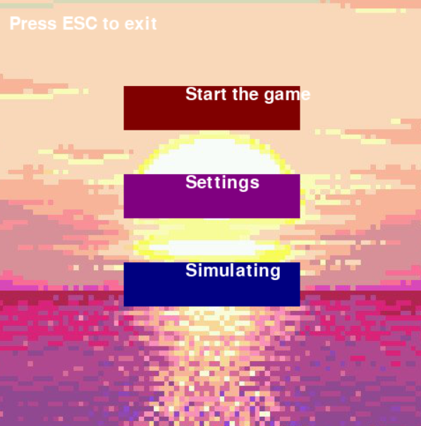

**For the home page:**

• The Esc key lets you go back.

• The mouse can be used to navigate through and choose any button.

• Results will be shown at the conclusion.

The following are the character controls:

• User 1 can move up, down, left, or right by using the keyboard keys "w," "s," "a," and "d."

• User 2 can move up, down, left, and right by pressing the keyboard's corresponding keys.

• User 3 uses the arrow keys on the keyboard to move up, down, left, and right.

• User 4 can move up, down, left, and right by using the keyboard keys "6," "7," "8," and "9."

**To the Setting Page:**

• The "esc" key can be used to return to the menu.

• By pressing the necessary buttons, a user can change the volume setting mode.

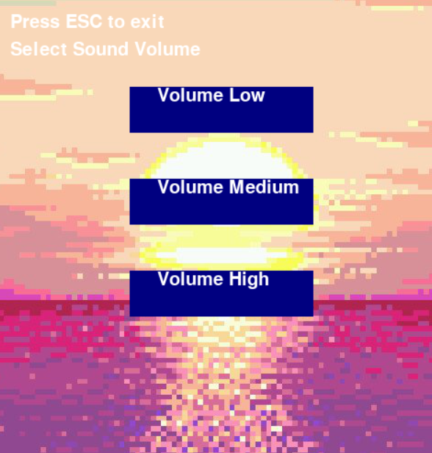

**Simulating**:

• The 'esc' key can be used to return to the menu.

• Users can choose from pre-made map sizes or upload their own.

• Following that, users can select between two, three, or four players.

• After selecting the player count, the simulation will begin.

• After the simulation, the random.txt file will receive the results.

